Jahnavi Mogarala
RA2411003020351
CSE F CORE
Dbms test

CREATE DATABASE college_db;
USE college_db;

CREATE TABLE students (id INT PRIMARY KEY, name VARCHAR(50), department VARCHAR(50), marks INT);

INSERT INTO students VALUES (1,'Aman','CSE',85),(2,'Riya','CSE',90),(3,'Karan','ECE',75),(4,'Neha','ECE',90),(5,'Arjun','MECH',60),(6,'Priya','MECH',40),(7,'Rahul','CSE',75);

- Display students who scored same marks as another student
SELECT s1.name,s1.marks FROM students s1 JOIN students s2 ON s1.marks=s2.marks AND s1.id<>s2.id;

- Find students who scored above their department average
SELECT name,department,marks FROM students s WHERE marks>(SELECT AVG(marks) FROM students WHERE department=s.department);

- Show department wise highest marks
SELECT department,MAX(marks) AS highest_marks FROM students GROUP BY department;

- Retrive students who are not in the department with lowest average marks
SELECT name,department FROM students WHERE department NOT IN (SELECT department FROM (SELECT department FROM students GROUP BY department ORDER BY AVG(marks) ASC LIMIT 1) AS temp);

- Display pass/fail using case (pass if marks> or = 50)
SELECT name,marks,CASE WHEN marks>=50 THEN 'PASS' ELSE 'FAIL' END AS result FROM students;

- Delete students who scored below overall average
DELETE FROM students WHERE marks < (SELECT avg_marks FROM (SELECT AVG(marks) AS avg_marks FROM students) AS temp);

Output screenshots

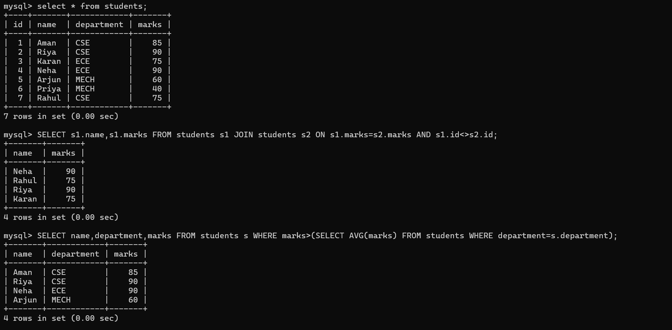
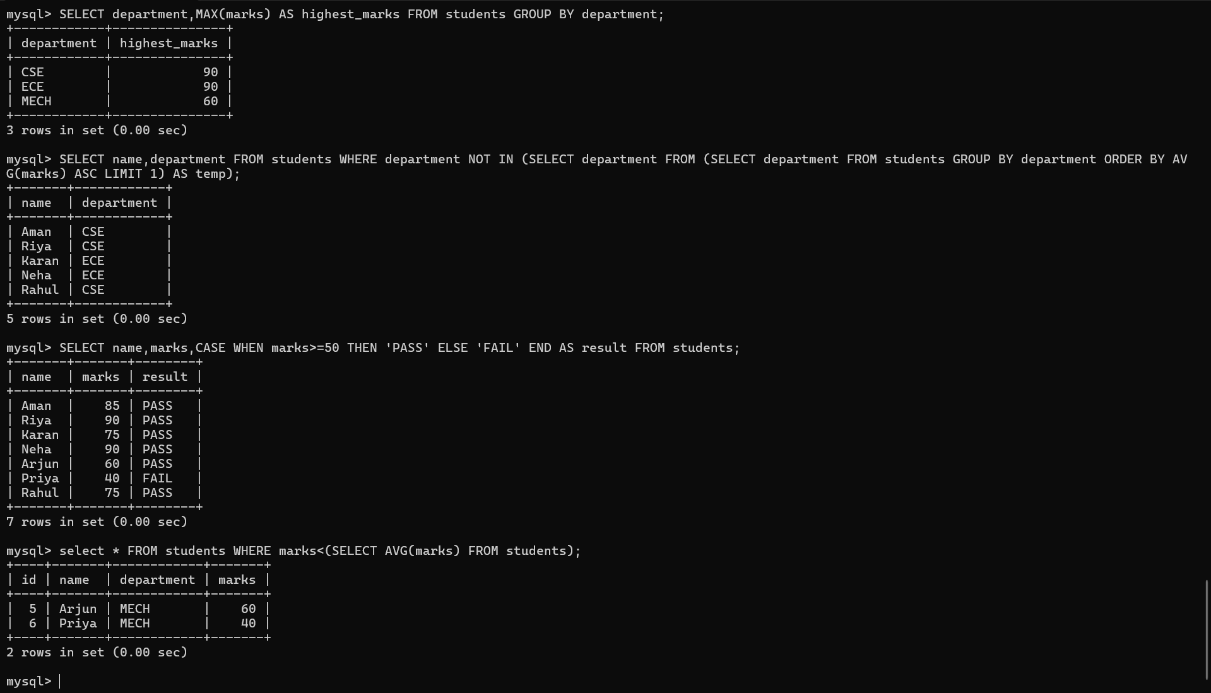


mysql> SELECT s1.name,s1.marks FROM students s1 JOIN students s2 ON s1.marks=s2.marks AND s1.id<>s2.id;
+-------+-------+
| name | marks |
+-------+-------+
| Neha | 90 |
| Rahul | 75 |
| Riya | 90 |
| Karan | 75 |
+-------+-------+
4 rows in set (0.00 sec)

mysql> show * from students;
ERROR 1064 (42000): You have an error in your SQL syntax; check the manual that corresponds to your MySQL server version for the right syntax to use near '* from students' at line 1
mysql> select * from students;
+----+-------+------------+-------+
| id | name | department | marks |
+----+-------+------------+-------+
| 1 | Aman | CSE | 85 |
| 2 | Riya | CSE | 90 |
| 3 | Karan | ECE | 75 |
| 4 | Neha | ECE | 90 |
| 5 | Arjun | MECH | 60 |
| 6 | Priya | MECH | 40 |
| 7 | Rahul | CSE | 75 |
+----+-------+------------+-------+
7 rows in set (0.00 sec)

mysql> SELECT s1.name,s1.marks FROM students s1 JOIN students s2 ON s1.marks=s2.marks AND s1.id<>s2.id;
+-------+-------+
| name | marks |
+-------+-------+
| Neha | 90 |
| Rahul | 75 |
| Riya | 90 |
| Karan | 75 |
+-------+-------+
4 rows in set (0.00 sec)

mysql> SELECT name,department,marks FROM students s WHERE marks>(SELECT AVG(marks) FROM students WHERE department=s.department);
+-------+------------+-------+
| name | department | marks |
+-------+------------+-------+
| Aman | CSE | 85 |
| Riya | CSE | 90 |
| Neha | ECE | 90 |
| Arjun | MECH | 60 |
+-------+------------+-------+
4 rows in set (0.00 sec)

mysql> SELECT department,MAX(marks) AS highest_marks FROM students GROUP BY department;
+------------+---------------+
| department | highest_marks |
+------------+---------------+
| CSE | 90 |
| ECE | 90 |
| MECH | 60 |
+------------+---------------+
3 rows in set (0.00 sec)

mysql> SELECT name,department FROM students WHERE department NOT IN (SELECT department FROM (SELECT department FROM students GROUP BY department ORDER BY AVG(marks) ASC LIMIT 1) AS temp);
+-------+------------+
| name | department |
+-------+------------+
| Aman | CSE |
| Riya | CSE |
| Karan | ECE |
| Neha | ECE |
| Rahul | CSE |
+-------+------------+
5 rows in set (0.00 sec)

mysql> SELECT name,marks,CASE WHEN marks>=50 THEN 'PASS' ELSE 'FAIL' END AS result FROM students;
+-------+-------+--------+
| name | marks | result |
+-------+-------+--------+
| Aman | 85 | PASS |
| Riya | 90 | PASS |
| Karan | 75 | PASS |
| Neha | 90 | PASS |
| Arjun | 60 | PASS |
| Priya | 40 | FAIL |
| Rahul | 75 | PASS |
+-------+-------+--------+
7 rows in set (0.00 sec)

mysql> select * FROM students WHERE marks<(SELECT AVG(marks) FROM students);
+----+-------+------------+-------+
| id | name | department | marks |
+----+-------+------------+-------+
| 5 | Arjun | MECH | 60 |
| 6 | Priya | MECH | 40 |
+----+-------+------------+-------+
2 rows in set (0.00 sec)

mysql> DELETE FROM students WHERE marks<(SELECT AVG(marks) FROM students);
ERROR 1093 (HY000): You can't specify target table 'students' for update in FROM clause
mysql> DELETE FROM students WHERE marks<(SELECT AVG(marks) FROM students);
ERROR 1093 (HY000): You can't specify target table 'students' for update in FROM clause
mysql> DELETE FROM students WHERE marks < (SELECT avg_marks FROM (SELECT AVG(marks) AS avg_marks FROM students) AS temp);
Query OK, 2 rows affected (0.01 sec)

mysql>

